LALPIR POWER LIMITED

PROFILE OF PERSONS CONTESTING ELECTION OF DIRECTORS TO BE HELD ON APRIL 26, 2017

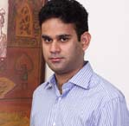
Mian Hassan Mansha

Mian Hassan Mansha has been serving on the Board of various listed companies for several years. He also serves on the Board of Nishat Power Limited, Security General Insurance Company Limited, Nishat Mills Limited, Pakgen Power Limited, Nishat Hotels and Properties Limited, Nishat (Aziz Avenue) Hotels and Properties Limited, Nishat (Raiwind) Hotels and Properties Limited, Nishat (Gulberg) Hotels and Properties Limited, Nishat Hospitality (Private) Limited, Nishat Dairy (Private) Limited, Pakistan Aviators and Aviation (Private) Limited, Nishat Automobiles (Private) Limited, Nishat Real Estate Development Company (Private) Limited and Nishat Agriculture Farming (Private) Limited, Nishat Farm Supplies (Pvt) Limited and Hyundai Nishat (Pvt) Limited.

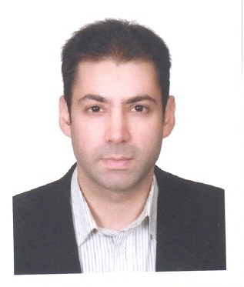
Mr. Aurangzeb Firoz

Mr. Aurangzeb Firoz is a graduate from the Lahore American School and of the University of London. He has recently completed his MBA from Cornell University, USA. His prime experience is focused in the areas of finance, business strategy and operation management. He is a director of City Schools Group and has been instrumental in providing strategic and operational support in driving business expansion into Arab States for City Schools’ (Pvt) Limited.

Mr. Aurangzeb Firoz holds directorships of Pakgen Power Limited, Engen (Pvt) Limited, Educational System (Pvt) Limited, City APIIT (Pakistan) (Pvt) Limited and City Hospitality Management Services (Pvt) Limited, his primary interest remains in the development of the new projects, especially in power and Energy and Educational Sector of Pakistan.

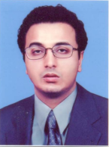
Mr. Jawaid Iqbal

Mr. Jawaid Iqbal is a Bachelor of Science from University of Pennsylvania, USA. He has over 19 years of vast experience of working as Chief Executive/Director of various Listed and non-listed companies. He also serves as Chief Executive Officer of Gul Ahmed CBMC Glass Company Limited and Metro Property Network (Pvt) Limited and Director on the Boards of Gul Ahmed Bio Films Limited and Metro Estate (Pvt) Limited.

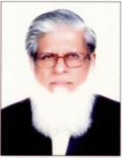
Mr. Khalid Qadeer Qureshi

Mr. Khalid Qadeer Qureshi is a fellow member of the Institute of Chartered Accountants of Pakistan. He has over 42 years of rich professional experience. He also serves on the Board of D.G. Khan Cement Company Limited, Nishat Power Limited, Lalpir Power Limited, Pakgen Power Limited Nishat Paper Products Company Limited, Pakistan Aviators and Aviation (Private) Limited and Nishat Spinning (Private) Limited.

Mr. Kamran Rasool
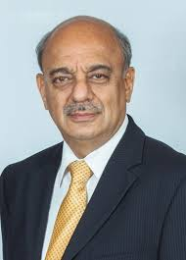
Mr. Kamran Rasool holds a Post Graduate Diploma in Development Administration from Manchester University and Masters in English from Punjab University. He was associated with Government of Pakistan as Secretary Defense, Cabinet Secretary, Secretary Industries and Production. Mr. Kamran Rasool is acting as the Advisor to President of MCB Bank Limited.

Mr. Kamran Rasool holds directorship on the Board of Pakgen Power Limited, Adamjee Insurance Company Limited, Nishat (Chunian) Limited and Nishat Chunian Power Limited.

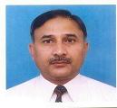
Mr. Muhammad Azam

Mr. Muhammad Azam is a fellow member of the Institute of Chartered Accountants of Pakistan he has over 37 years’ of experience He is working as Sr. General Manager (F& A) with Nishat Mills Limited since 1991 and also held office of director in Security General Insurance Company Limited.
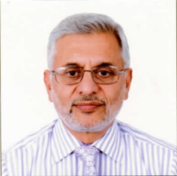
Mr. Mahmood Akhtar

Mr. Mahmood Akhtar holds an MBA degree from Punjab University and has over 36 years of managerial experience spread across various industries. He also serves on the Board of Pakgen Power Limited, Nishat Power Limited, Security General Insurance Company Limited, Nishat Hospitality (Pvt) Limited, Nishat Spinning (Pvt) Limited

